Assignment Manager – Release Mark for Individual Student

Overview

We’ve enhanced the Assignment Manager application to allow teachers to release marks for individual students within an assignment. Previously, teachers had to mark all students before releasing the marks overall.

This improvement enables teachers to provide immediate feedback to students who complete their assignments early, supporting their personal learning journey.

How-to

To release a mark for an individual student, go to Assignment Manager > Assignments and select the assignment you wish to review. In this example, we’ll select the assignment Lesson 2 - Attributes of a healthy and tasty meal.

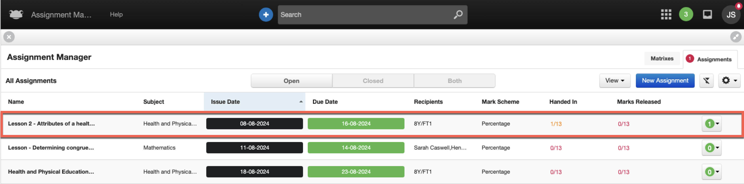

Select the student for whom you want to release the mark. In the assignment Lesson 2 - Attributes of a healthy and tasty meal, the activity and overall mark for the student Tracy Rauch have already been completed. Now, we’re simply looking to release this mark and comments to the individual student, Tracy Rauch, while keeping the assignment open for the other students.

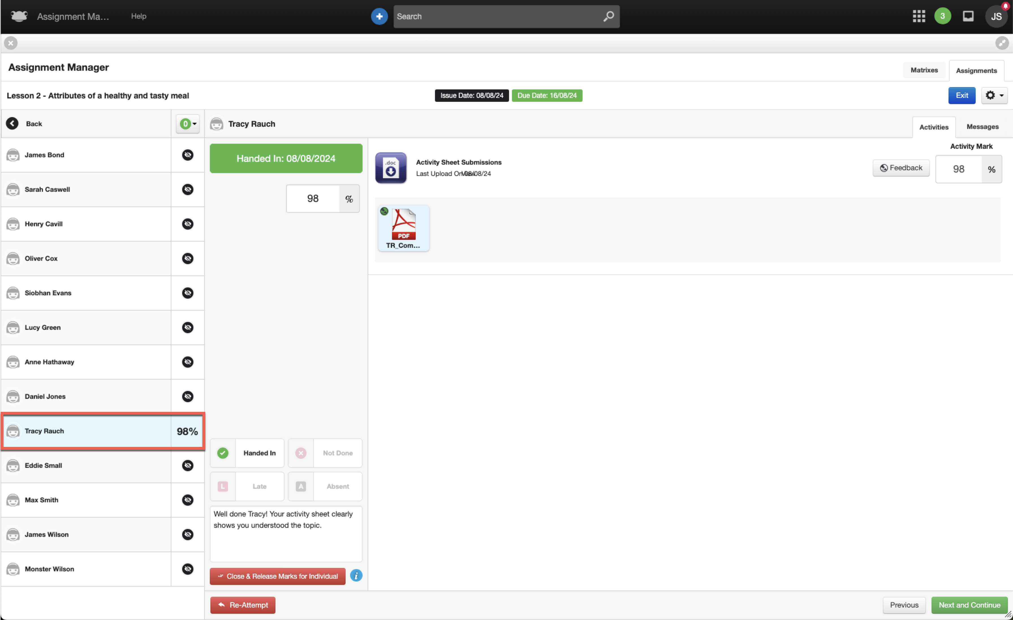

To release the marks for an individual student, select the Close & Release Marks for Individual button within the assignment.

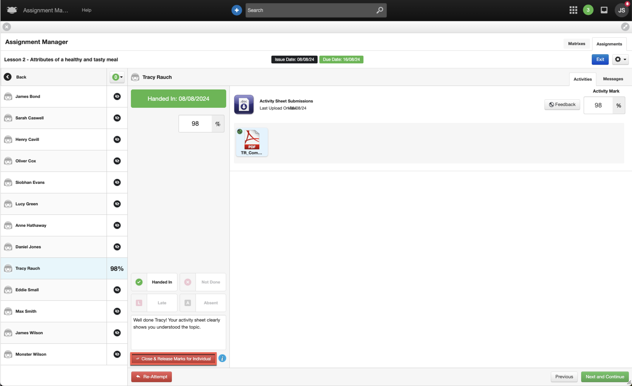

The assignment for the student Tracy Rauch will update, and you will notice the following changes:

- In the assignment status overview column, a blue tick will appear in the top right-hand corner. This new icon indicates that the marks have been released for the individual student.
- In the marking panel, the teacher will see a new green button labelled Reopen for Individual. This button allows the teacher to reopen the assignment for the selected student to adjust their marks.

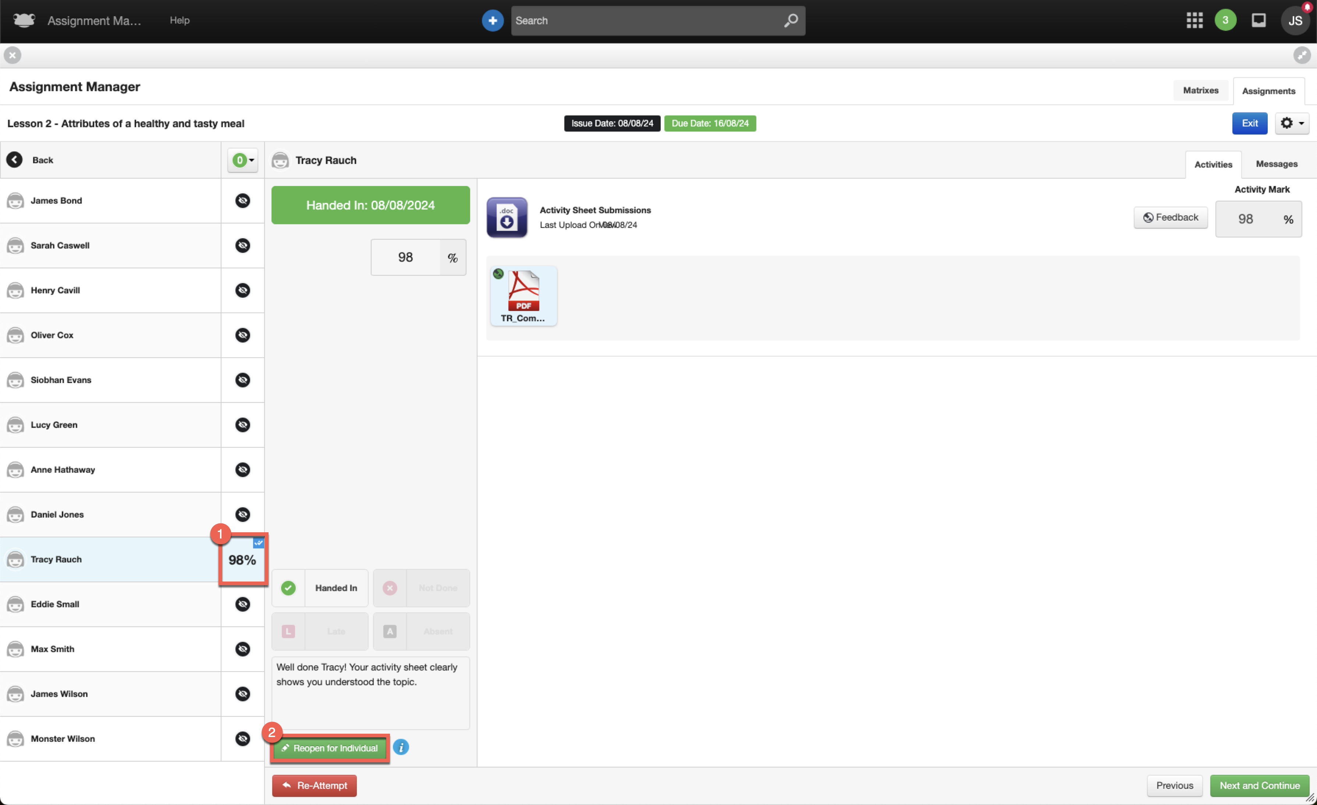

If we now switch to the student view, the changes will look the same as when marks are released for an entire class. When a student’s marks are individually released, they will first be notified via a notification on their timeline that their assignment has been marked.

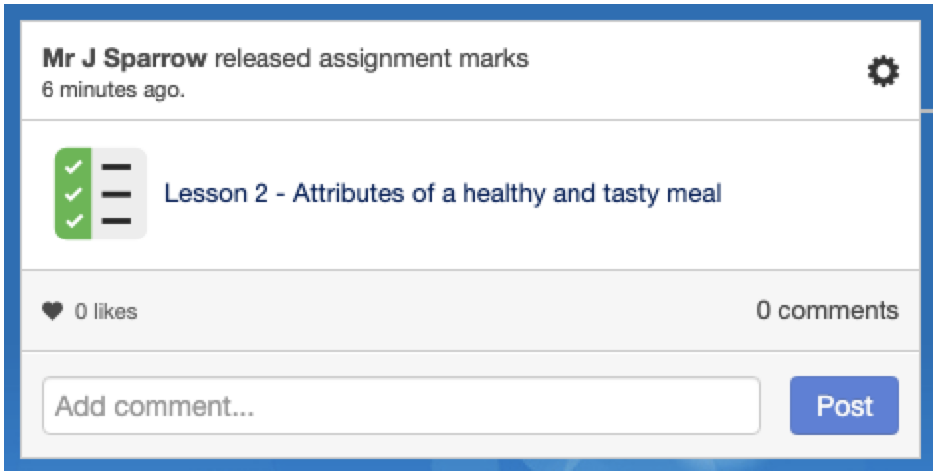

When the student selects the assignment timeline event, the Assignments application will launch, displaying their activity mark, any comments left by the teacher, and their overall mark.

NOTE – The assignment will appear to the student within the Assignments application under the Closed tab.

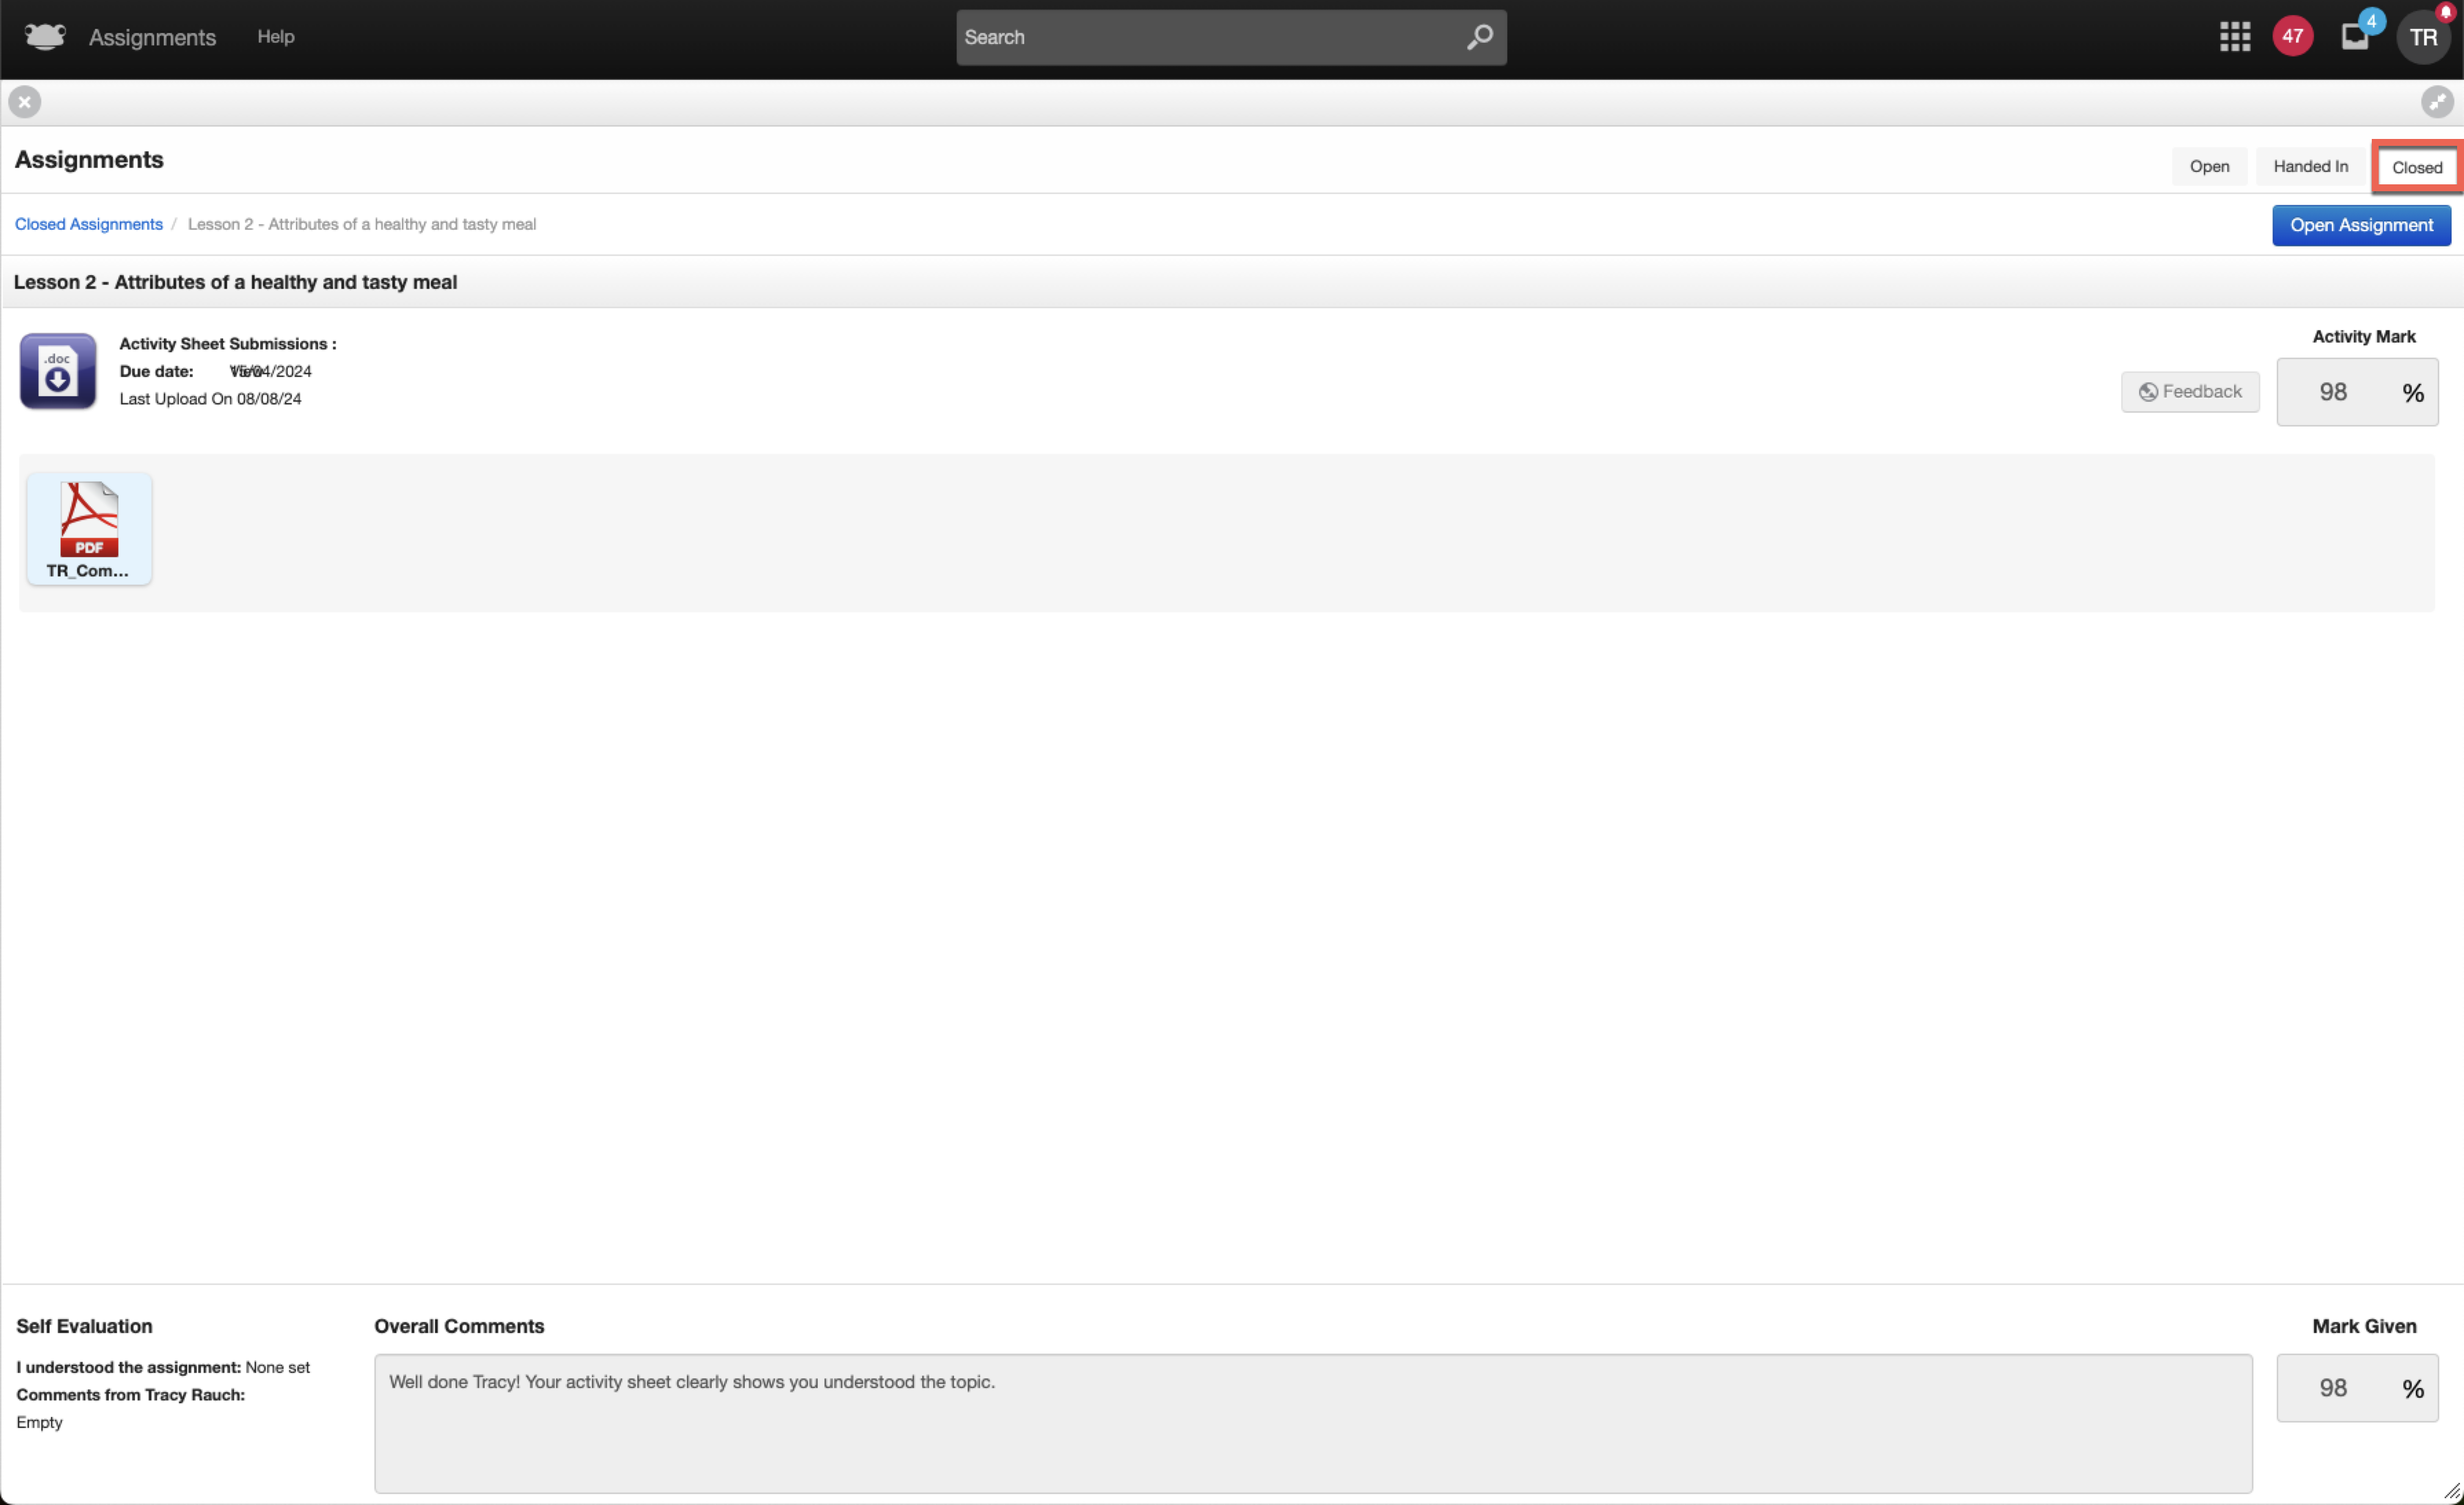

If the student has the Notifications widget on their dashboard or navigates to the Profile Menu > Notifications, they will see two notifications for the individual assignment:

- One notification informing the student that the teacher has released their mark and what that mark was.
- Another notification advising that the assignment has been closed.

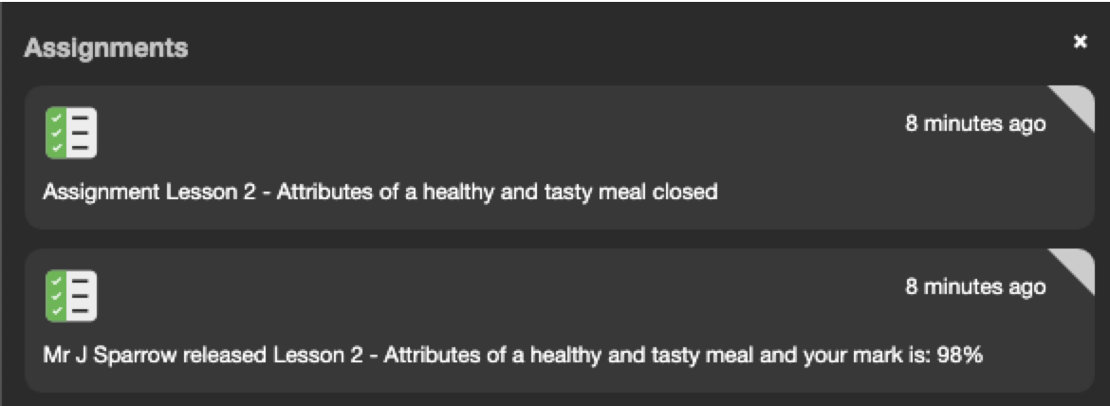

We’ll now switch back to the teacher view of the assignment Lesson 2 - Attributes of a healthy and tasty meal within the Assignment Manager application.

In the status overview column, we can see that students are in various states:

- James Bond, Tracy Rauch and Monster Wilson have had their marks released individually, indicated by the blue tick in the top right-hand corner.
- Oliver Cox and Ann Hathaway has viewed their assignment but not completed it, indicated by a greyed-out tick.
- Henry Cavill and James Wilson has had their assignment marked by the teacher and percentage displayed, but their mark has not yet been released.
- All other remaining students have not yet viewed their assignment, indicated by an icon of an eye with a line through it.

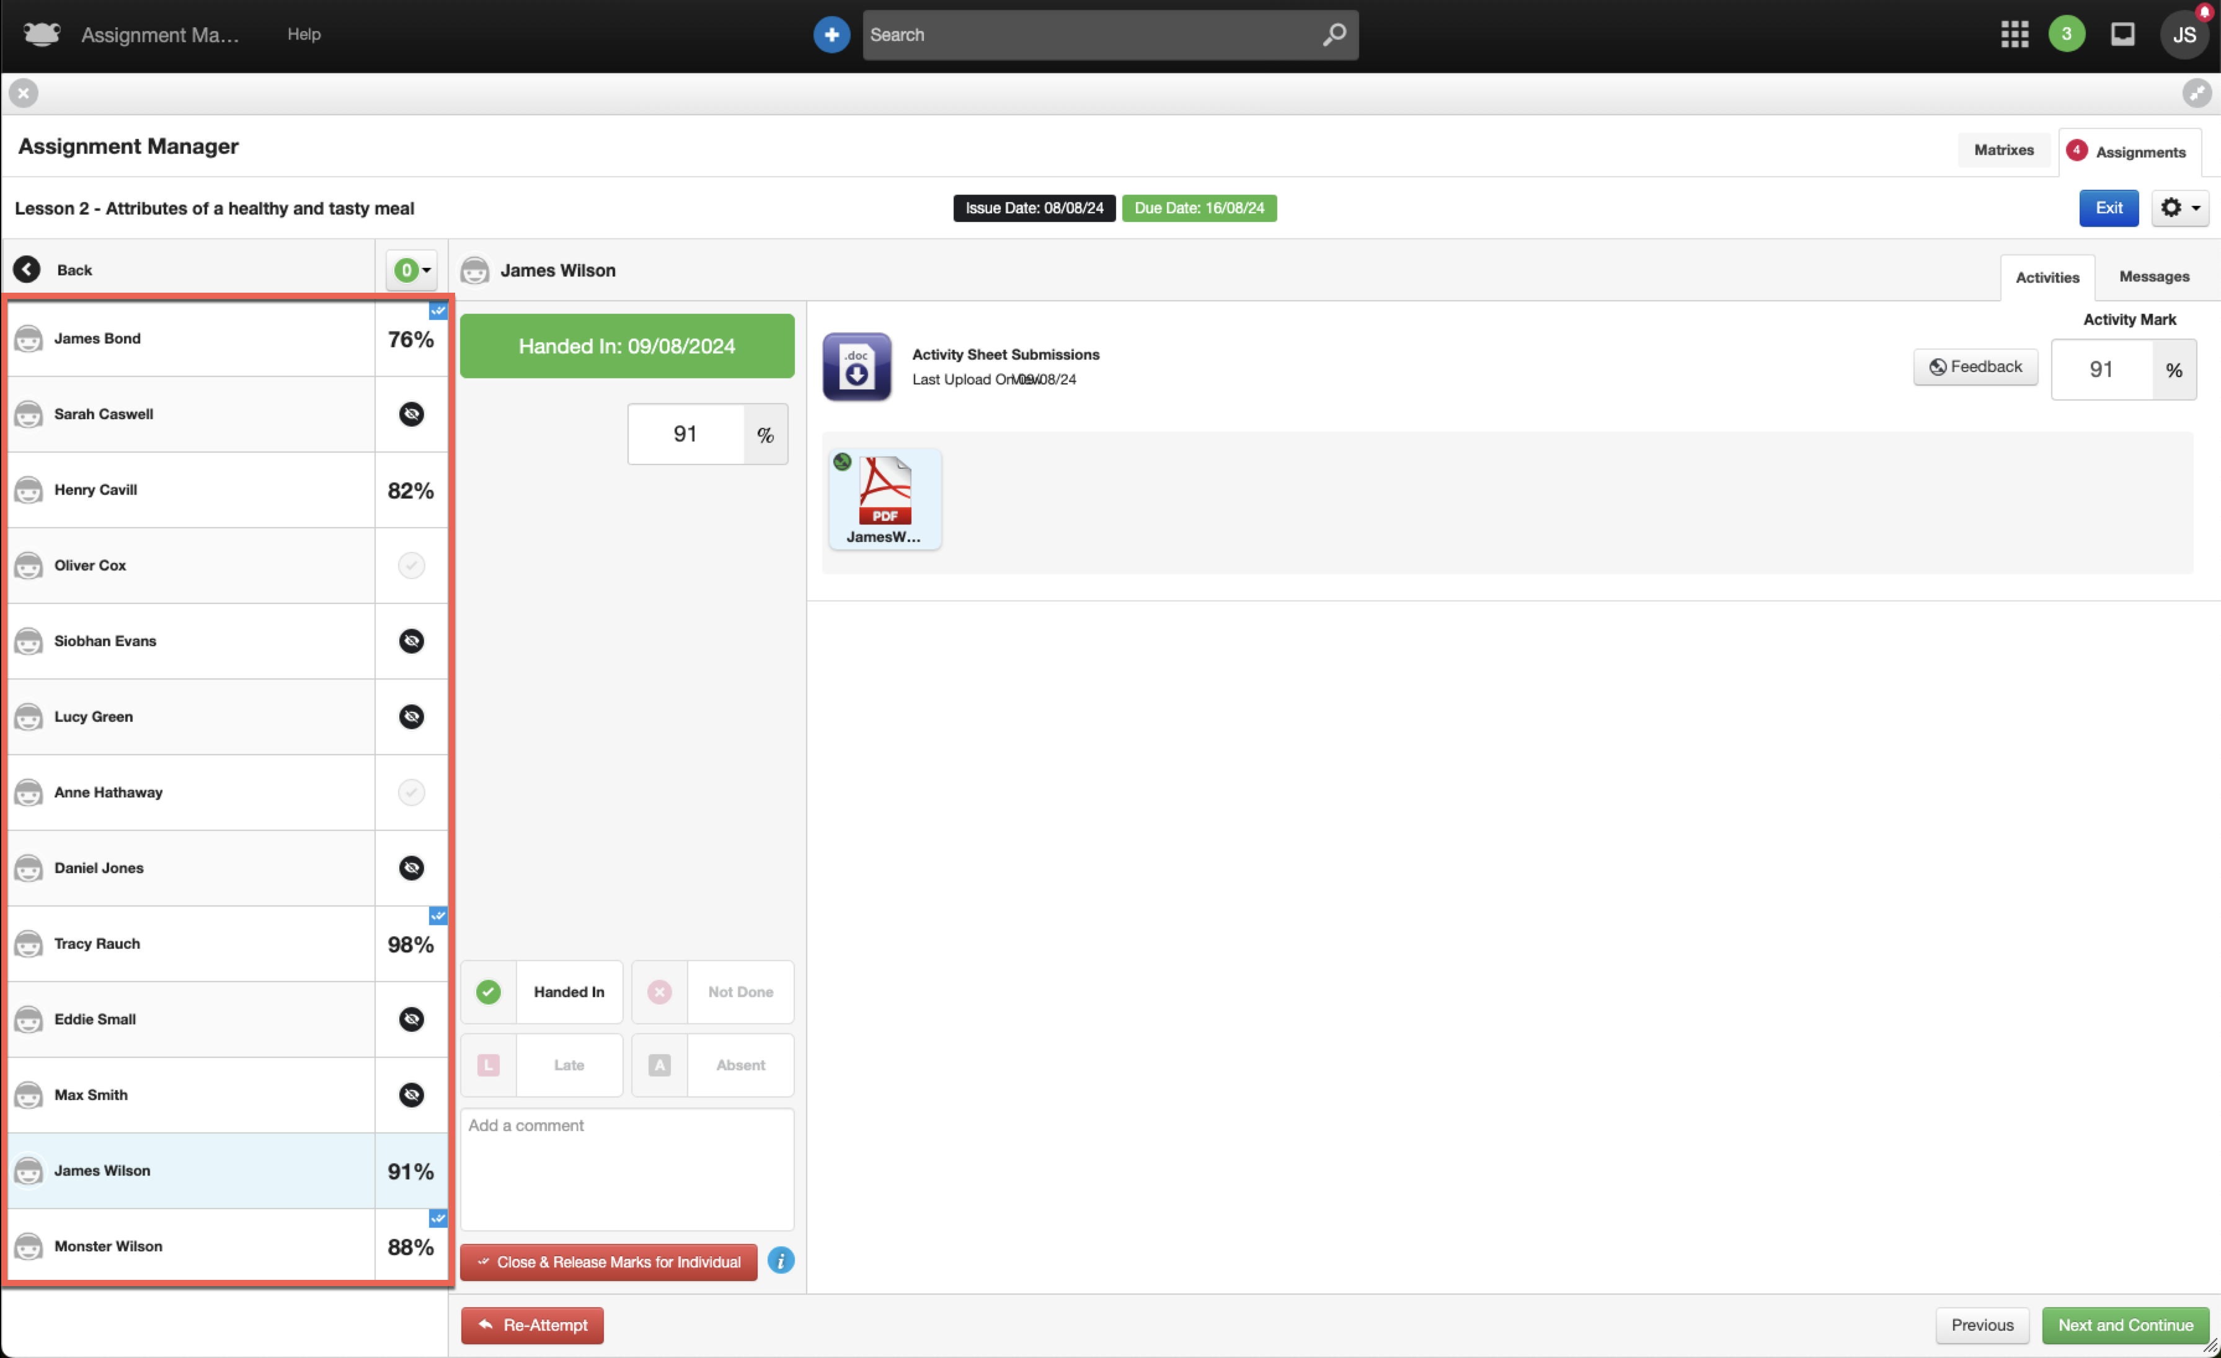

Once all assignments have been marked, the process is the same as before; navigate to the popover and select the Close and Release Marks button.

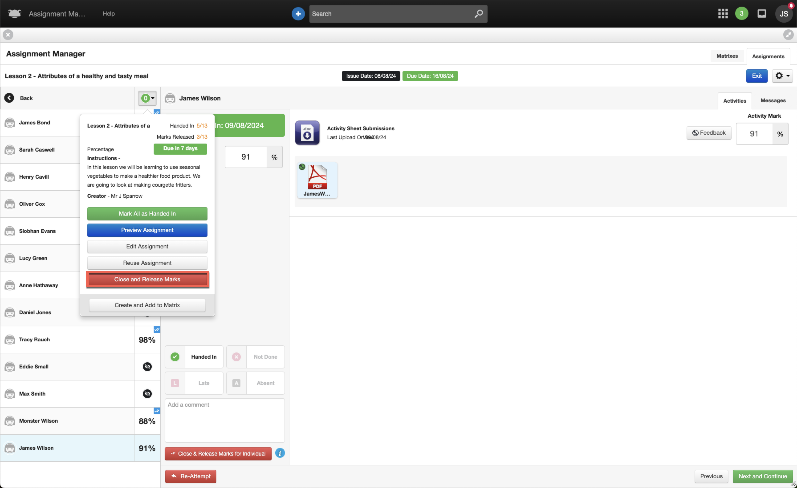

The Close Assignment popup window is displayed. With the ability to release marks for individual students, there is a new option within this window that allows the teacher to Only close assignment for individuals with marked submissions. This option enables the teacher to quickly bulk close the assignment for students who have been marked.

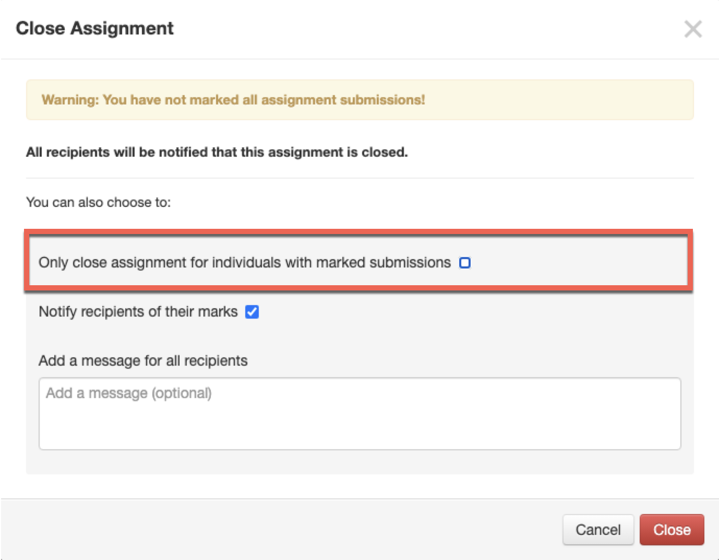

In this example, the assignment will be closed overall, even though some students haven’t been marked. The default option Notify recipients of their marks will remain selected, and then select the Close button.

This action will close the assignment, and any students who haven’t had their marks released will be notified of their marks.

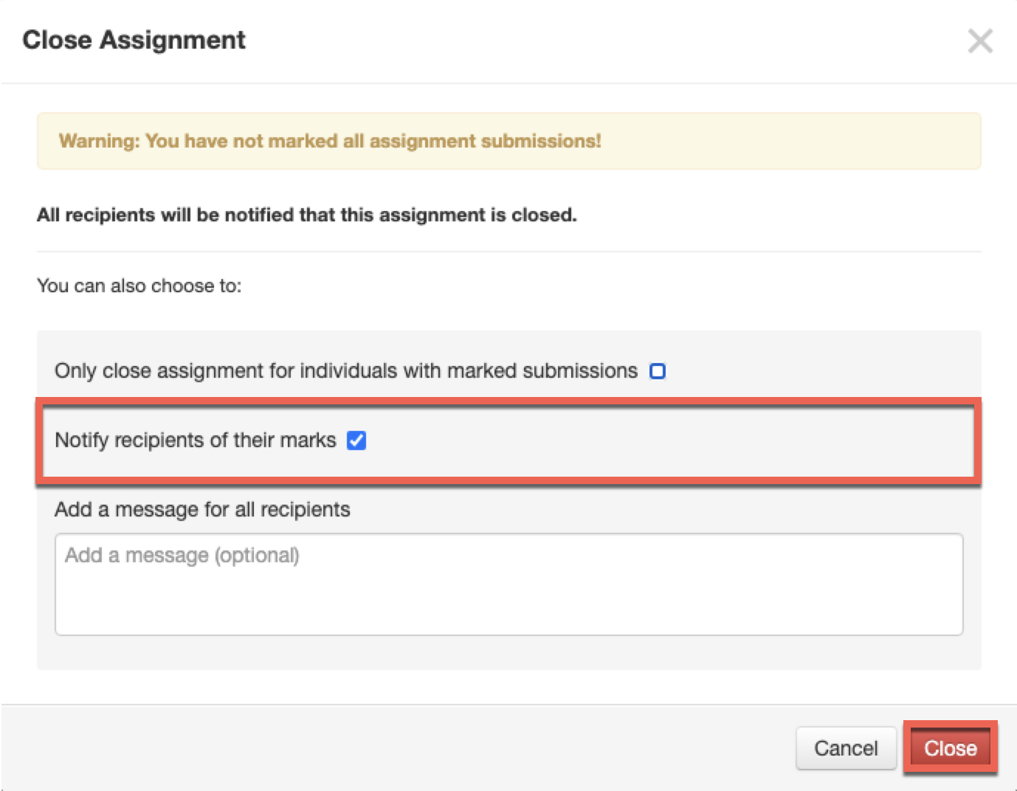

The teacher will be taken back to the assignment, and the following changes will be seen within the status overview column:

- Students (James Bond, Tracy Rauch and Monster Wilson) who had their marks individually released will display their mark but no longer have a blue tick displayed.
- Students (Henry Cavill and James Wilson) who had had a mark entered but not released individually will have their mark displayed.
- Students who have not completed their assignment will have a status of Not Done displaying a red cross.

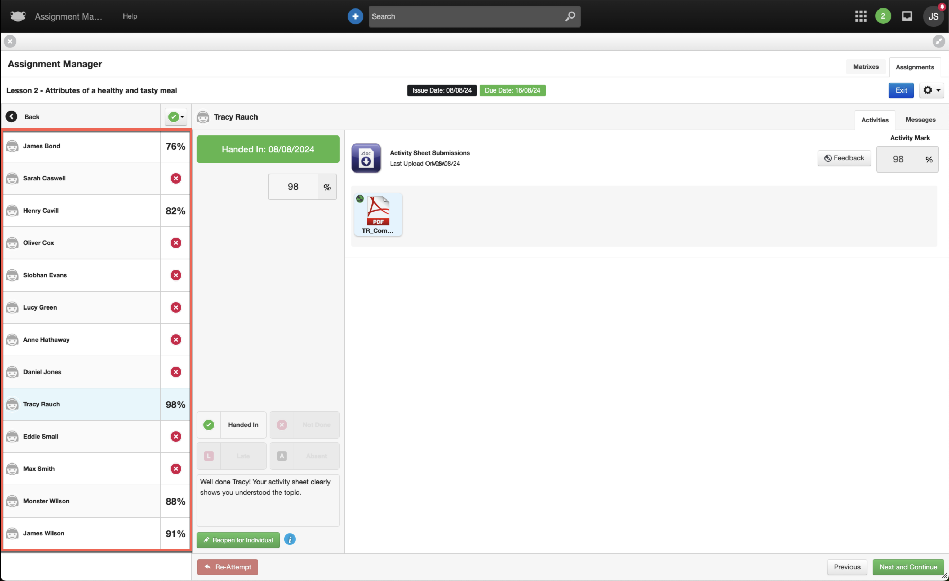

If a teacher wishes to reopen an assignment for an individual student after it has been closed, they can do so by navigating to the closed assignment and selecting the student. A new button, Reopen for Individual, will be available.

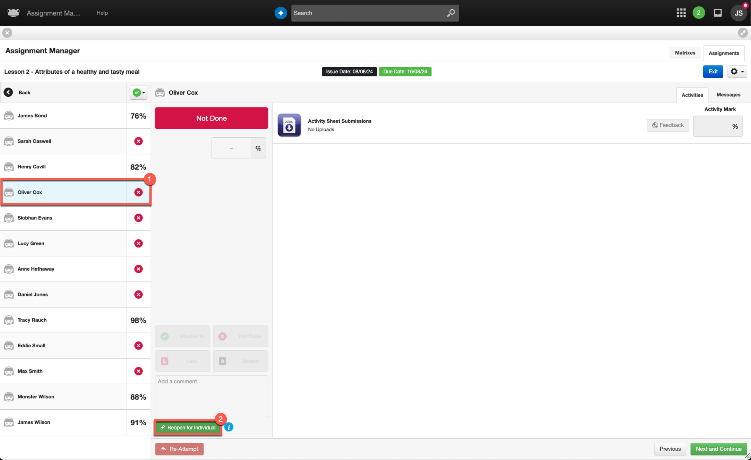

When the teacher reopens an assignment for an individual student, a few differences will be seen. The first of these is within the status overview column, with the following changes:

- A blue tick will appear in the top right-hand corner for all students whose assignments remain closed with marks released.
- Students with an overall mark set will have their mark displayed.
- Students who did not complete their assignment (either not viewing it or viewing it but not handing it in) will have a status of Not Done, indicated by a red cross.

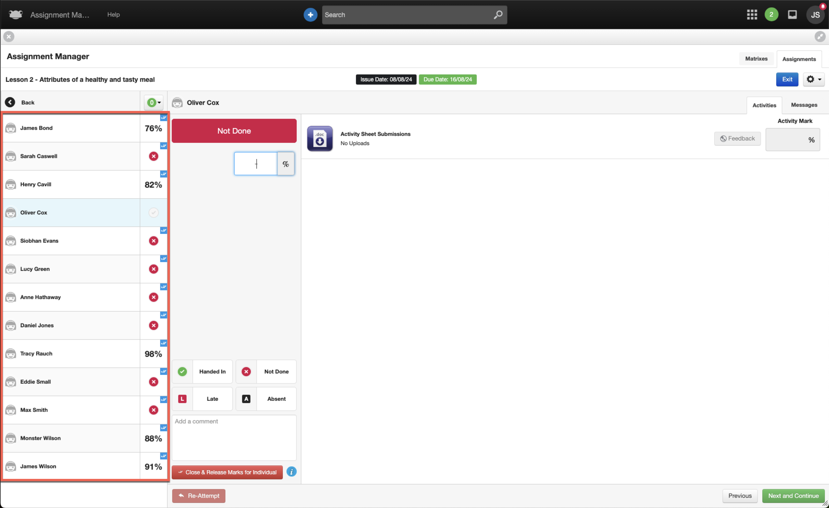

When the assignment is reopened for an individual student, the teacher will notice the following changes in the assignment list view:

- The assignment will now appear within the Open tab.
- The Marks Released column will show all marks released, excluding any students for whom the assignment was reopened individually.

In this example, the assignment Lesson 2 - Attributes of a healthy and tasty meal will display the Marks Released column as 12/13, since the assignment was only reopened for an individual student, Oliver Cox.

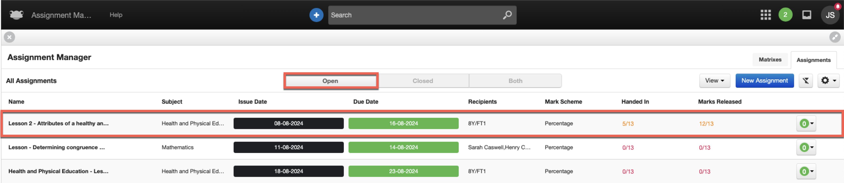

If we go back into the reopened assignment, Lesson 2 - Attributes of a healthy and tasty meal, we can see that Oliver Cox, for whom the assignment was reopened individually, displays his status as it was prior to the assignment being closed. In this case, Oliver Cox did not complete his assignment, and the status shows a greyed-out tick.

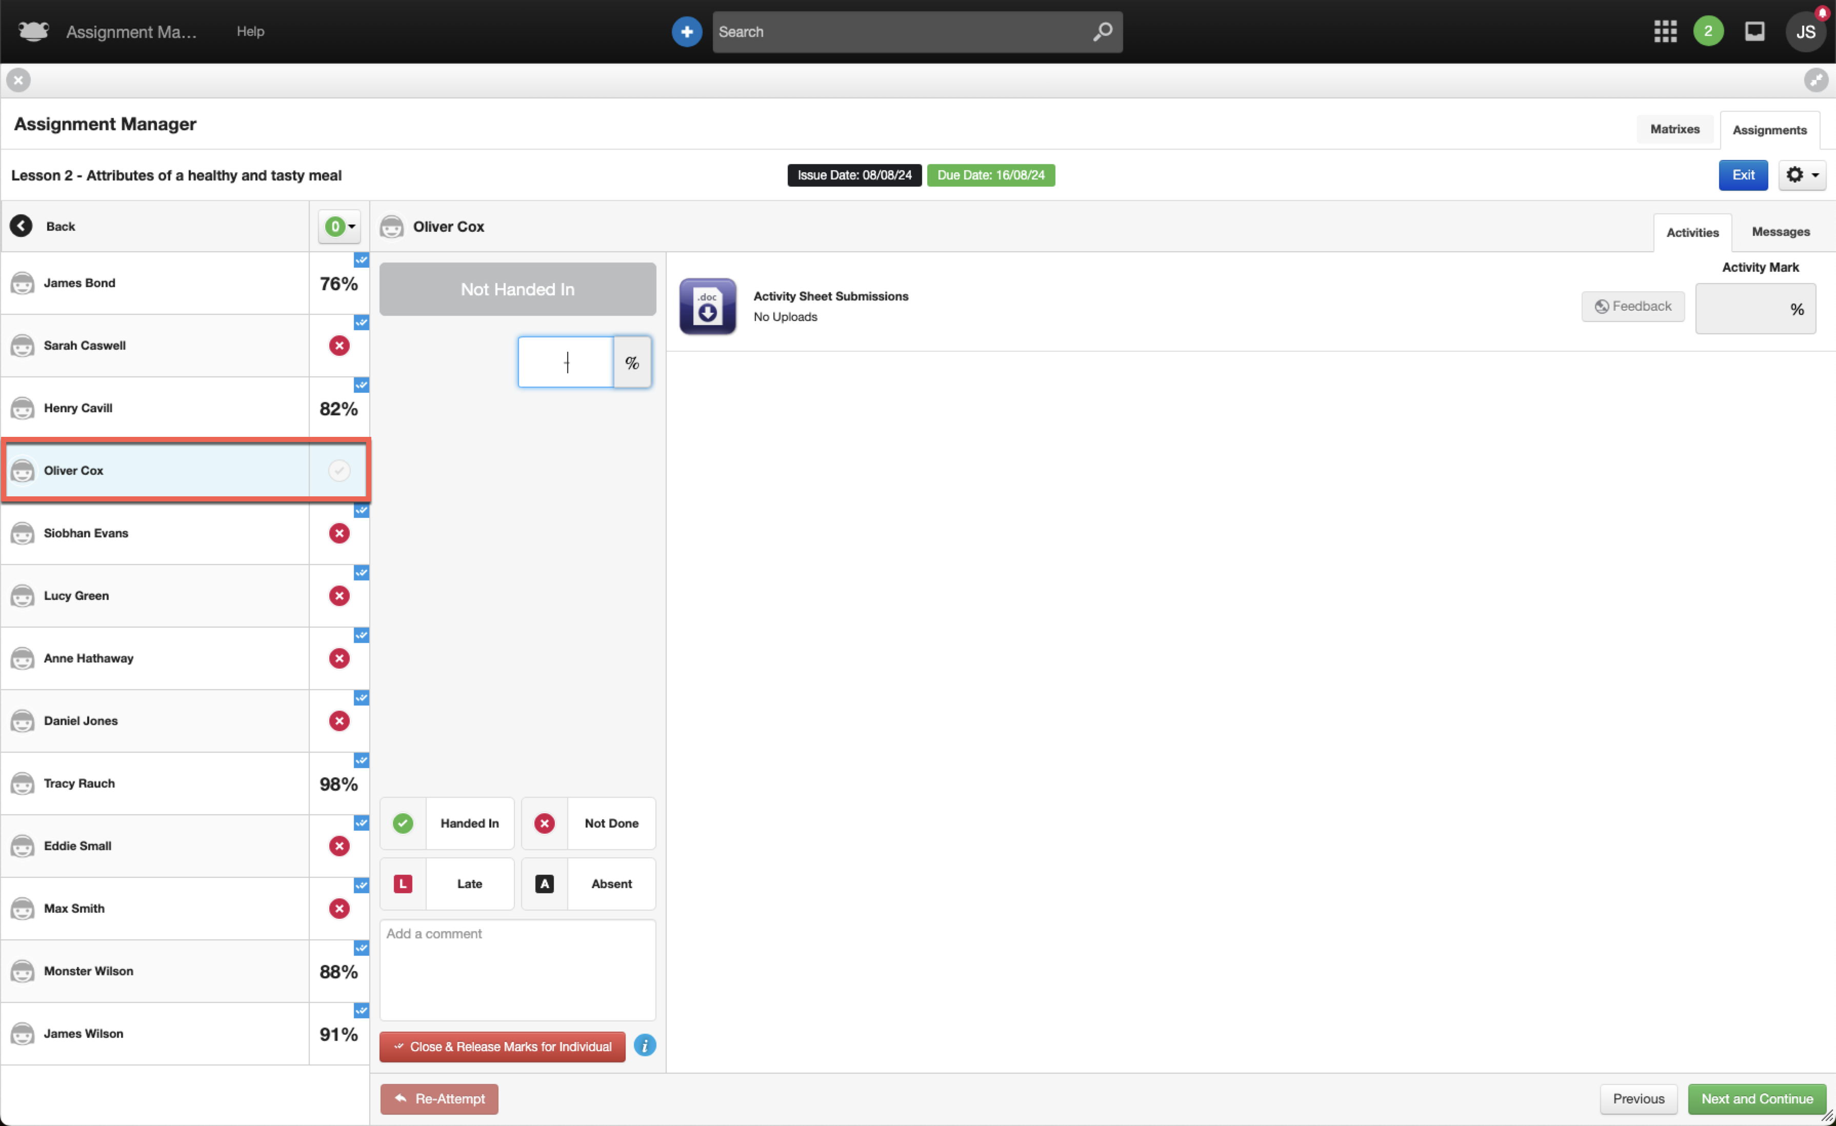

From a student perspective, the assignment will reappear in the Assignment application under the Open tab, ready for them to complete.

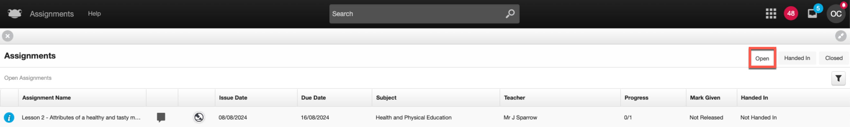

The final scenario we’ll look at is when a teacher wishes to reopen an assignment for the entire class. In this case, the teacher navigates to a closed assignment, selects the popover, and then clicks the Reopen Assignment button.
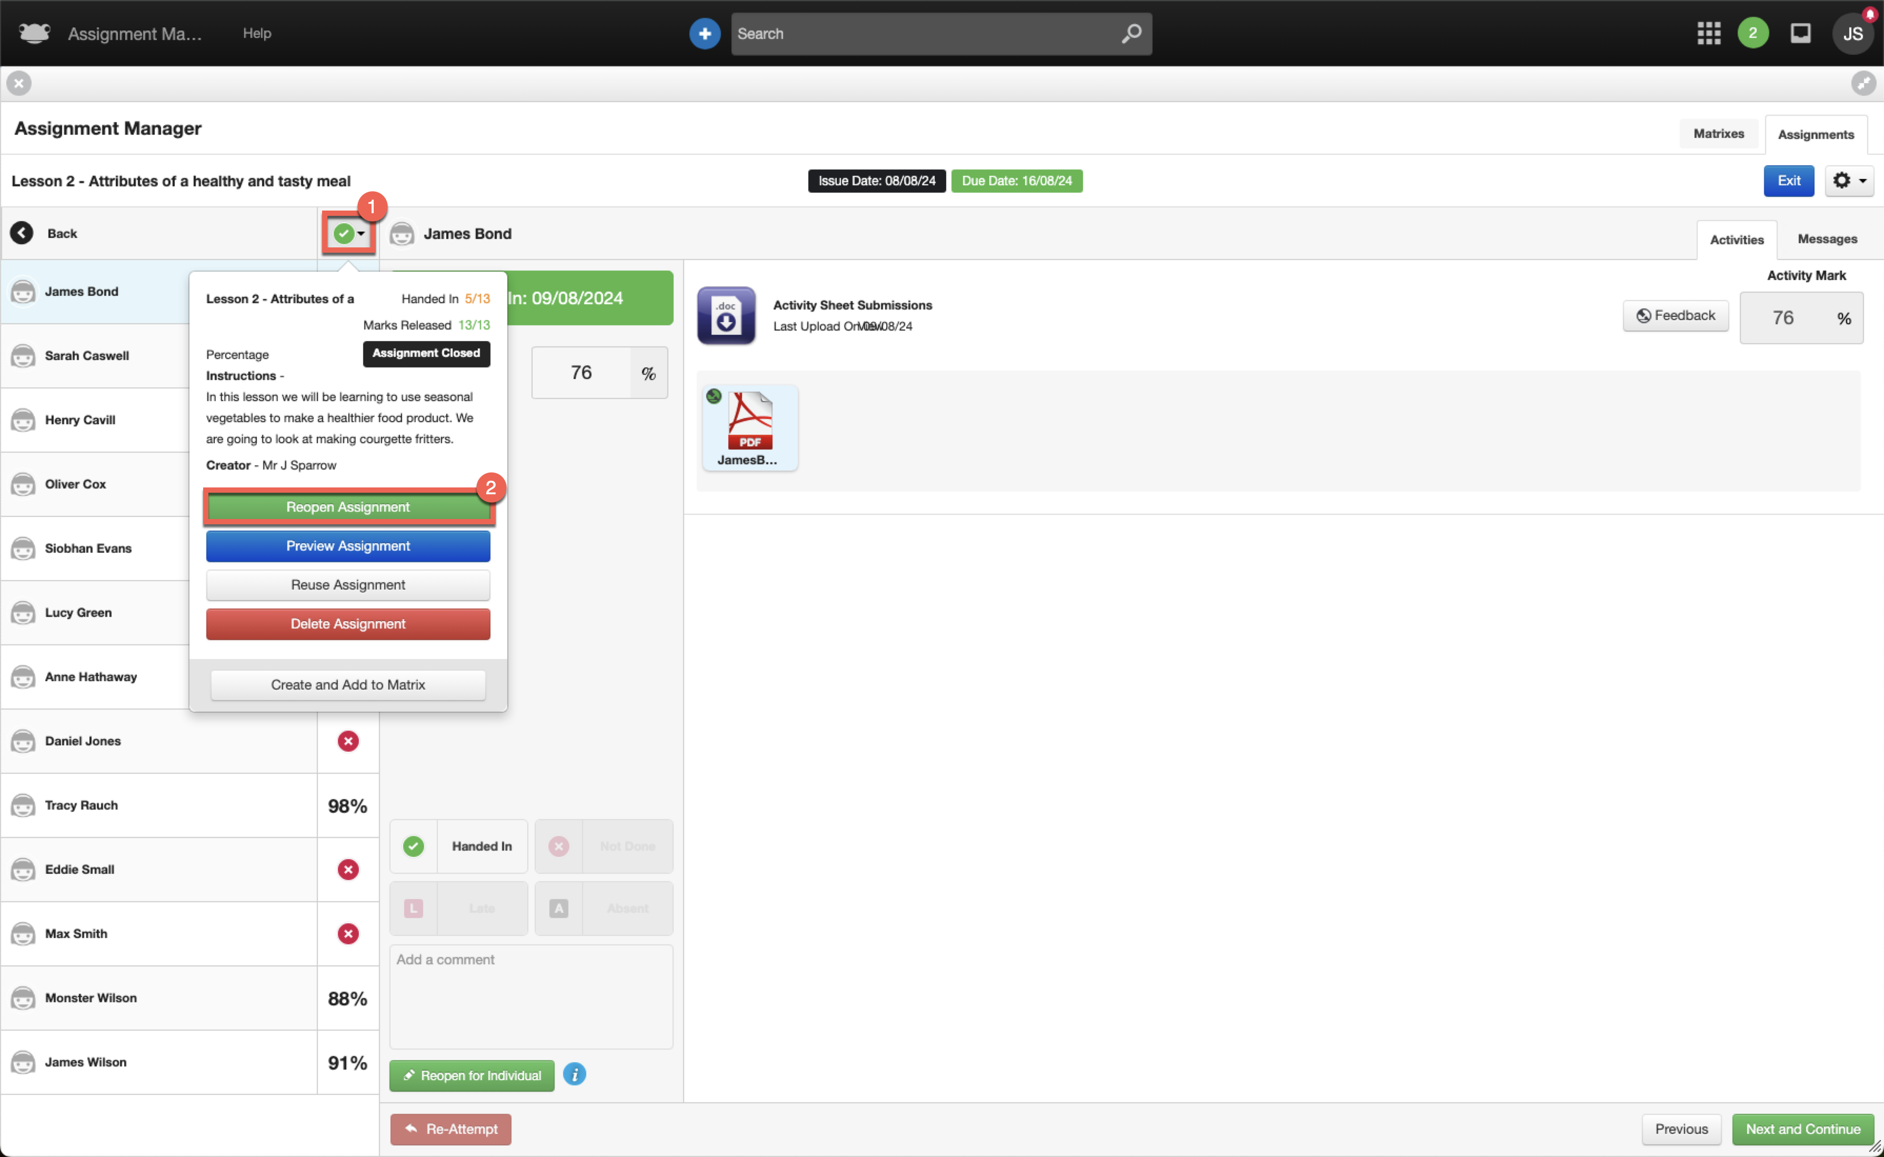

When the teacher reopens an assignment for an entire class, a few differences will be seen compared to reopening it for an individual student. The first of these changes are visible within the status overview column:

- No blue ticks will appear in the top right-hand corner for any students, even those who had their marks released individually before.
- Students with an overall mark set will have their mark displayed.
- Students who did not complete their assignment will have their original status displayed:
  - If a student did not view their assignment, an icon of an eye with a line through it is displayed.
  - If a student viewed their assignment but did not complete it, a greyed-out tick is displayed.

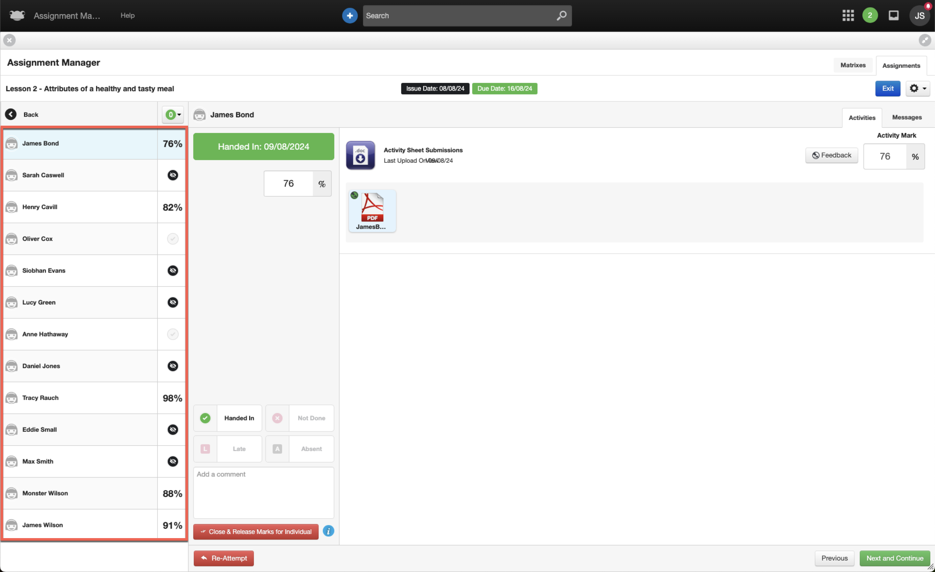

When the assignment is reopened for an entire class, the teacher will notice the following changes in the assignment list view:

- The assignment will now appear within the Open tab.
- The Marks Released column will show that no marks have been released, even for students whose marks were previously released individually.

In this example, the assignment Lesson 2 - Attributes of a healthy and tasty meal will display the Marks Released column as 0/13, since the assignment was reopened for the entire class. It is assumed that in this situation, the teacher intends to review the assignment overall, including any marks previously released.

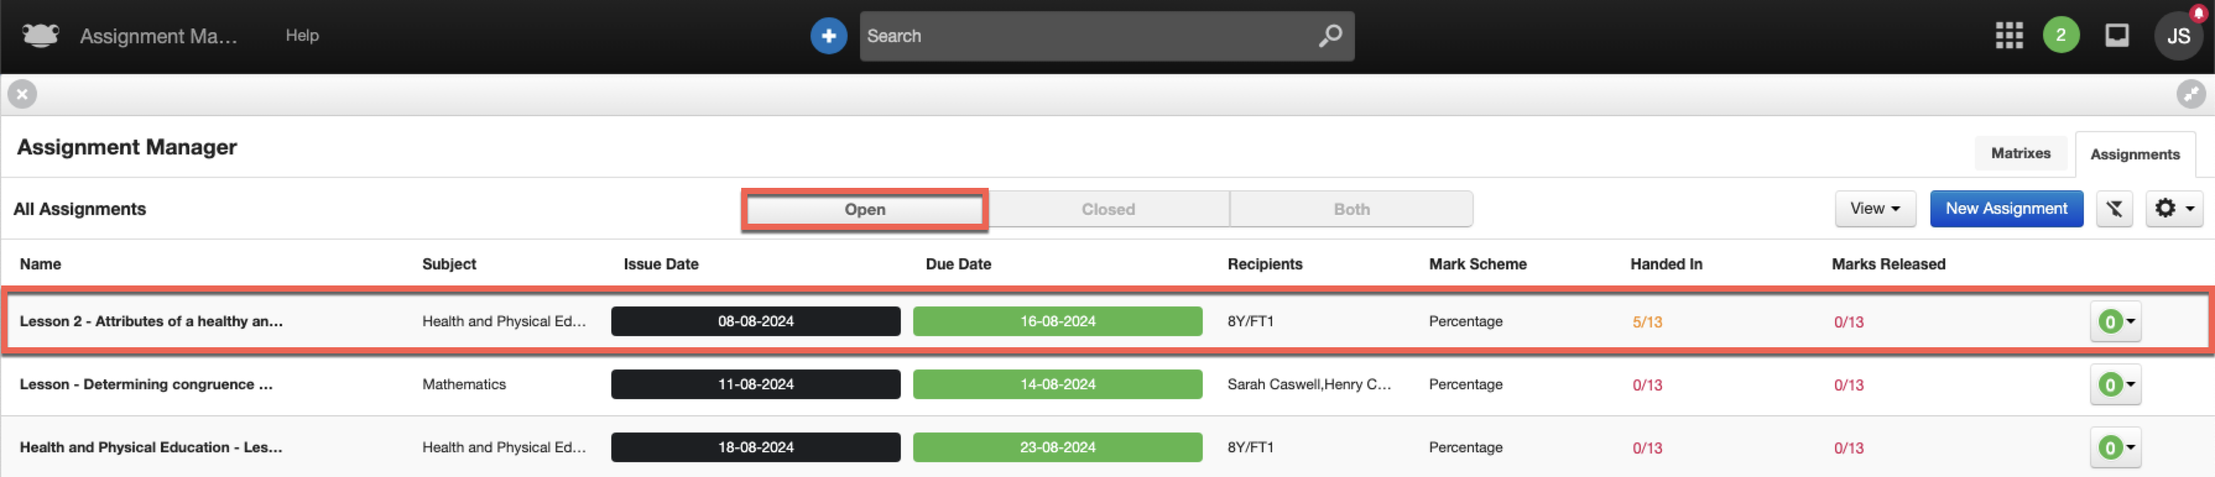

From a student’s perspective across the entire class, the assignment will reappear in the Assignments application. However, depending on their status before the assignment was closed, it may appear under different areas.

For example, students who did not view their assignment or did not hand it in will find the assignment under the Open tab, ready for them to complete.

On the other hand, students who handed in their assignment—and for whom the teacher may have entered an overall mark but not yet released it — will see the assignment under the Handed In tab, with no further action required from them.

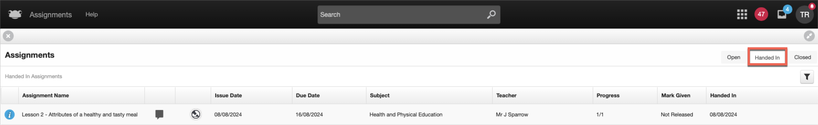

Additional Information

Below are some additional changes within Assignment Manager to help teachers quickly and clearly identify the number of students who have had their marks released for an individual assignment.

Within the Assignment tab of Assignment Manager, a new column titled Marks Released has been added. This column summarises the number of students who have had their marks individually released compared to the original number of students the assignment was set for.

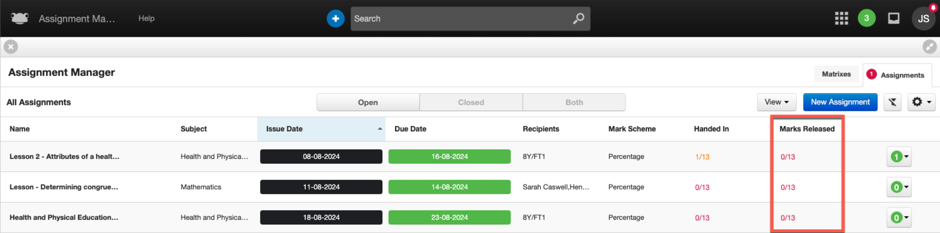

The Marks Released column will follow the same colour coding as the Handed In column, with the field highlighted in one of the following colours:

- Green – All students have had their marks released for the assignment.

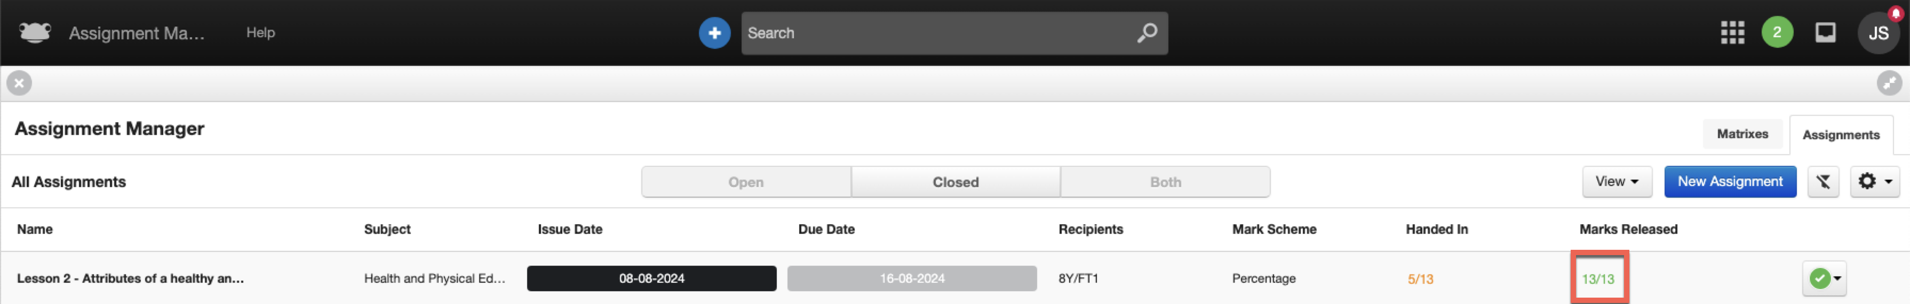

- Amber – One or more students have had their marks released for the assignment.

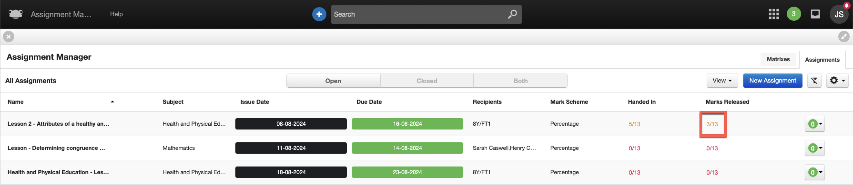

- Red – No students have had their marks released for the assignment.

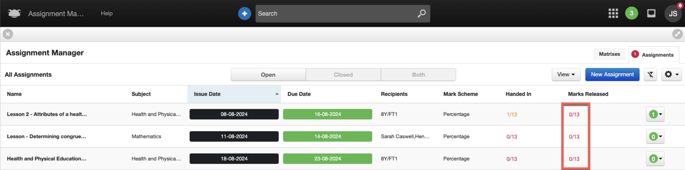

If you select the popover, you’ll find a Marks Released field that highlights the number of students who have had their marks individually released compared to the original number of students the assignment was set for. This field follows the same colour coding as mentioned above.

Below is a view of the popover and the new Marks Released field when selected for a particular assignment within the assignment list overview.

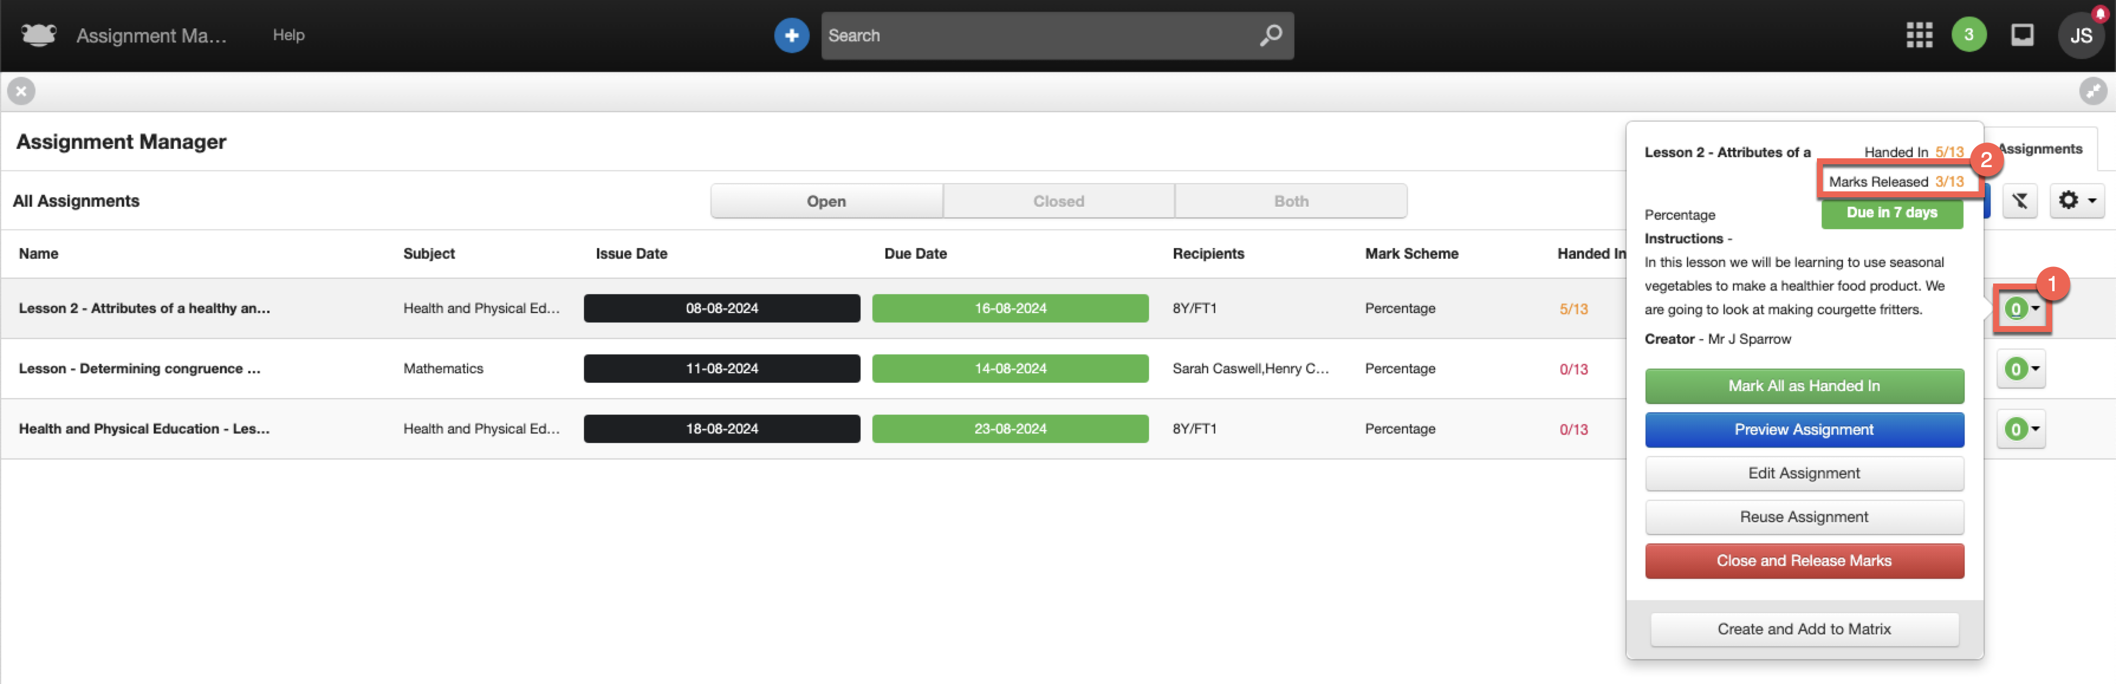

Below is a view of the popover and the new Marks Released field when selected within an assignment.

