Bugs Resolved

Below is a list of bugs resolved and minor enhancement in the Earhart patch release v18.0.75 / v2106_2_57

Groups and Policies Application

Frog Reference | CSD Reference |  | ALM# | Summary
SA-277 |  | N/A | N/A | Within the Groups and Policies application, the policy role below for the “Admin” profile will be automatically enabled for all existing Frog platforms as well as for any new platforms that are created.  Apps > Users > Login as User > ON

Notice Board Widget (Enhancement)

Frog Reference | CSD Reference |  | ALM# | Summary
N/A |  | N/A | N/A | Based on customer feedback, the Notice Board widget has been enhanced to assist users in viewing and admins in managing notice board entries.  The enhancement introduces the following tabs:  - Read – Users can view all new notice board entries they have read.  - Unread – Users can view all read notice board entries.  - Expired – Admins only can view all expired notice board entries.  By default, users will automatically be taken to the Unread tab to view all new notice board entries.  Example of a teacher view of a notice board with the Unread tab selected:  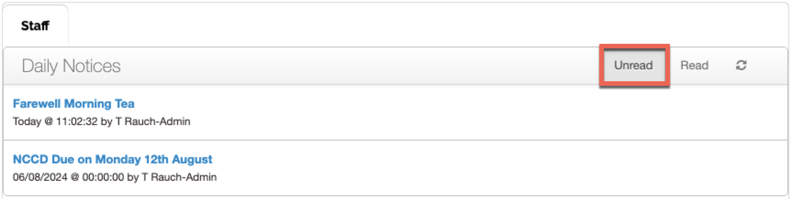  Once a user selects a notice board entry to view its details and then navigates back, the notice board entry will be moved into the Read tab.  Example of a teacher view of a notice board with the Read tab selected:  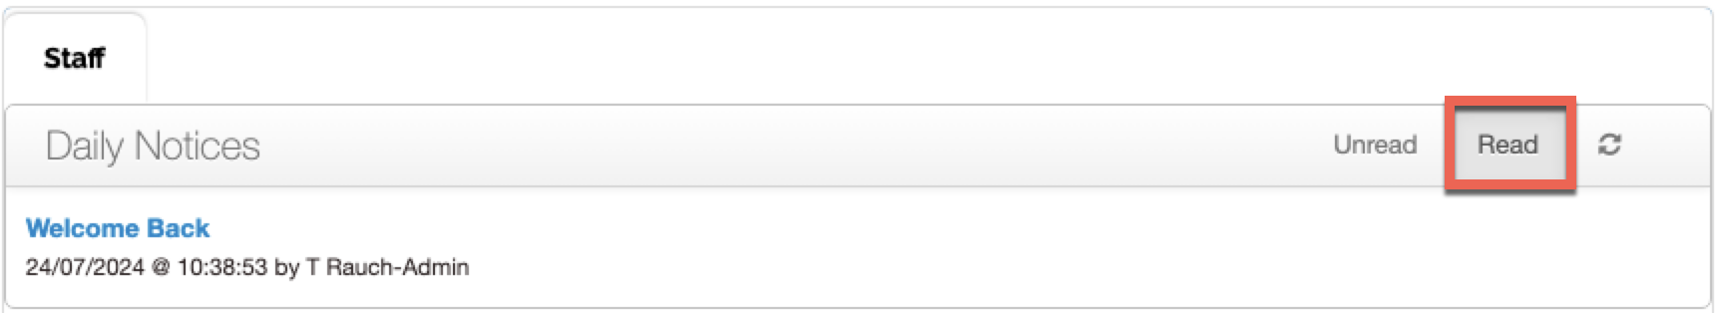  Admins will have access to an additional tab, Expired, within the Notice Board widget. The Expired tab displays all notice board entries that have surpassed their set date.  Example of an admin view of a notice board with the Expired tab selected:  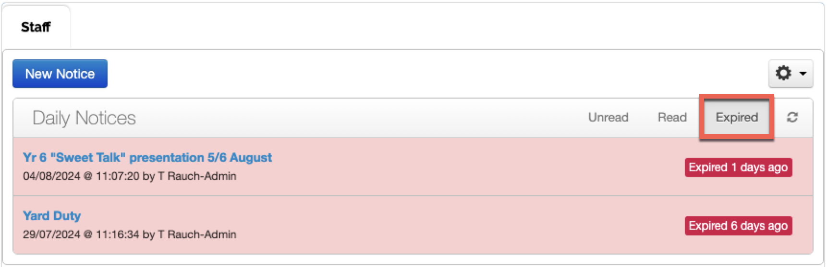  When an admin selects either the Unread or Read tabs, they will also see any notice board entries scheduled for future dates.  Example of an admin view of a notice board with the Unread tab selected and a notice board entry set to display on a future date:  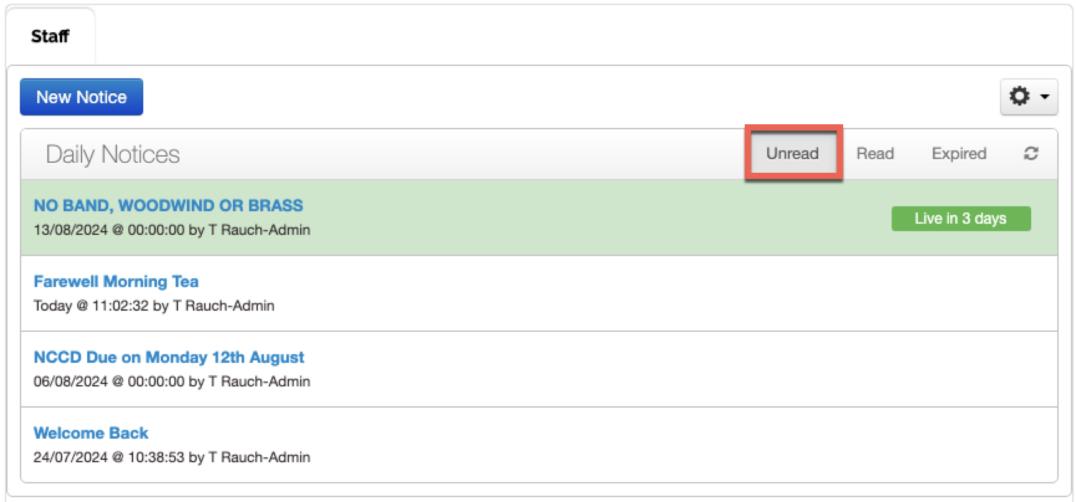  NOTE - If the Notice Board widget is set to “Show Detail of the entry,” a user must still click on the message for it to move from the Unread tab to the Read tab.

